**Assignment 2**

By Harsh Sharma

Output

**Part I. Table Creation**

**2.** Input data into the tables using the provided **EliteVideoData.sql** file.

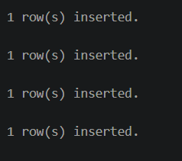

Part 2.

1.

2.

3.

4.

5.

6.

7.

8.

9.

10.

11.

12.

13.



14.

15.

16.

17.

**Part 3**

1.

2.

3.

Part 4.

1.



2.



3.



4.



5.



6.



7.



**2**. **Method Definitions**

1. **No output**

**3. Creating Object Tables**

**1.**

**2.**

**3.**

**4. Inserting Values.**

**1.**



**2.**

**3.**

**4.**

